


Echoes
Compass Informatics Statement of work
AWS ARCHITECTURE

Commercial and in confidence
Version 1.0 June 1, 2023

ECHOES

VERSION: 1.0.0 | REVISION DATE: [Date]

Approval of the Terraform Architecture indicates an understanding of the purpose and content described in this deliverable. By signing this deliverable, each individual agrees with the content contained in this deliverable.

Approver Name | Title | Signature | Date

Echoes Technical Architecture Page 1 of 16

Document Scope
This document describes the AWS Architecture of the ECHOES and why we choose AWS as cloud computing architecture.

The goal of this document is to explain the differences between the could providers and how we implemented the AWS.

Overall, of Cloud Computing Architecture

Cloud computing is the on-demand availability of computer system resources, especially data storage and computing power, without direct active management by the user. Large clouds often have functions distributed over multiple locations, each of which is a data center.

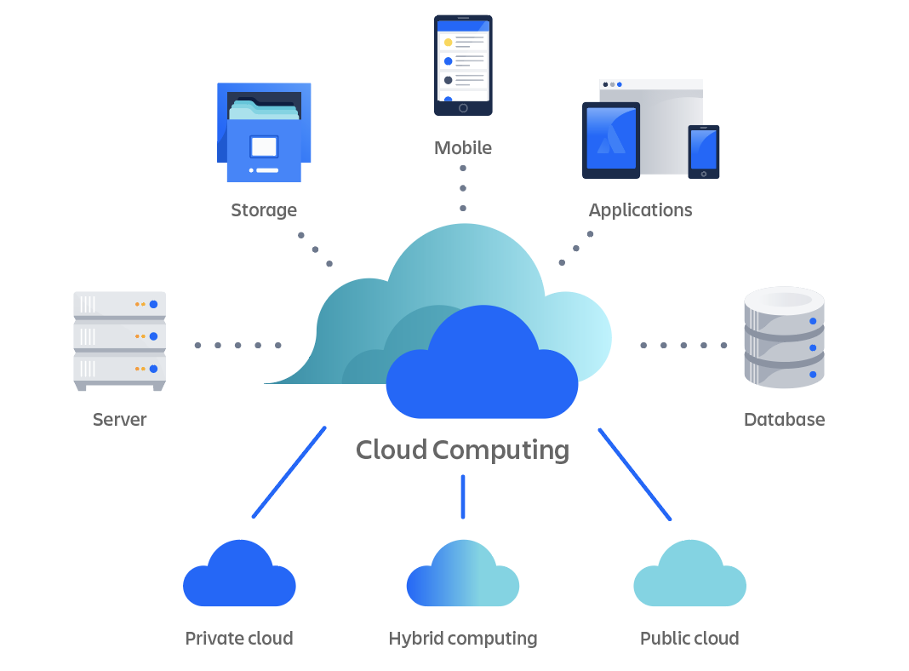
Currently the market offer many clouding computing service but the 3 top are :
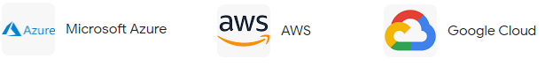
For the Echoes platform we decided to go with AWS or Amazon Web Services which is the cloud platform offered by Amazon that provides scalable and cost-effective cloud computing solutions.
AWS is the world’s leading cloud provider that provides a wide range of services to build and scale all kinds of applications. You can use AWS for anything from hosting a personal website for as cheap as 1$ to 1.5$ to large-scale enterprise applications. AWS has its customers in over 190 countries, and leading companies like Kellogg’s, Netflix, and Airbnb use AWS as their cloud provider.
Here is some reasons why we chose AWS:
1 - Global Leader
With the rise in cloud computing AWS is coming out as a clear winner compared to other cloud providers. It has a 32% market share – more than the next two cloud providers combined.
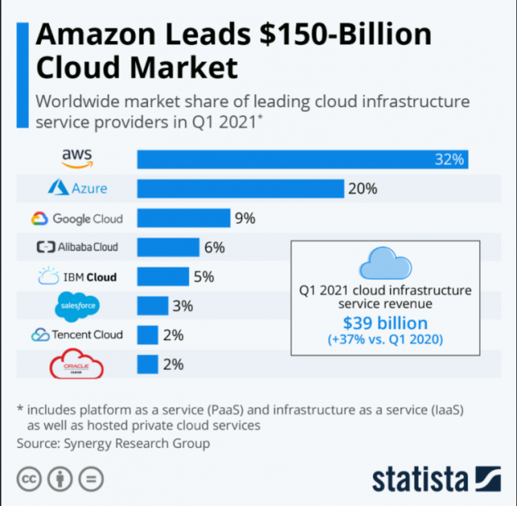
2 - AWS Global Infrastructure

As of now, the AWS Cloud spans 84 Availability Zones in 26 regions worldwide. Further, the company has announced plans for 24 more Availability Zones and 8 more AWS Regions in multiple countries across the world. The global presence of AWS allows you to set up your applications in multiple major cities across the globe, providing low latency access to your customer. This should also help you set up multi-region backups.

3- Simplicity

AWS is designed brilliantly to allow developers to get comfortable with the platform quickly. AWS is constantly upgrading its console to improve the UI experience of the developers. They have good descriptions and color-coding of information to help new users understand the console better.

4 - Performance

For the most part, AWS never goes down. You can check for any current or old outages in AWS services in the AWS Health Dashboard.

AWS allows you to massively scale your applications to create highly efficient architectures that scale up and down as needed.

5 - Security

AWS is a secure platform. It offers a free IAM (Identity and Access Management) service that allows you to implement fine-grained policies for users in your AWS account. You can use IAM to allow and deny users to perform an action in your AWS account. AWS also offers the AWS Config service that can help you implement compliance controls in your AWS accounts.

AWS is a clear leader in the cloud computing world, and it offers a lot of unique features.

What we used for the AWS Infrastructure

VPCs | Europe | 2
Subnets | Europe | 4
Route Tables | Europe | 3
Inernet Gateways | Europe | 2
Network ACLs | Europe | 2
Security Groups | Europe | 9
EC2 Instance | Europe | 3
RDS | Europe | 1
CodeDeploy | Europe | 1

Resource map

